**Day 22**

**this keyword in Java**

There can be a lot of usage of **Java this keyword**. In Java, this is a **reference variable** that refers to the current object.

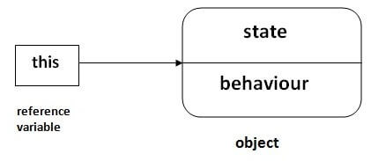

Usage of Java this keyword

Here is given the 6 usage of java this keyword.

1. [this can be used to refer current class instance variable.](https://www.javatpoint.com/this1)
2. [this can be used to invoke current class method (implicitly)](https://www.javatpoint.com/this2)
3. [this() can be used to invoke current class constructor.](https://www.javatpoint.com/this3)
4. [this can be passed as an argument in the method call.](https://www.javatpoint.com/this4)
5. [this can be passed as argument in the constructor call.](https://www.javatpoint.com/this5)
6. [this can be used to return the current class instance from the method.](https://www.javatpoint.com/this6)

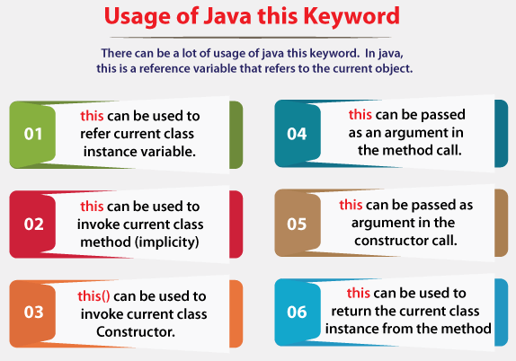

Super Keyword in Java

The **super** keyword in Java is a reference variable which is used to refer immediate parent class object.

Whenever you create the instance of subclass, an instance of parent class is created implicitly which is referred by super reference variable.

Usage of Java super Keyword

1. super can be used to refer immediate parent class instance variable.
2. super can be used to invoke immediate parent class method.
3. super() can be used to invoke immediate parent class constructor.

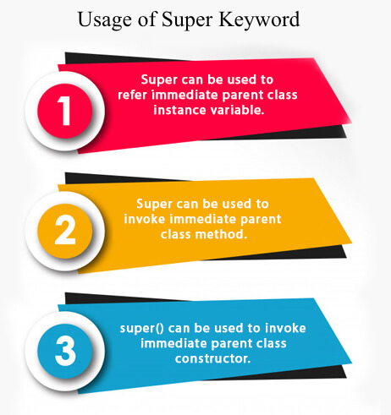

**Questions**

### 1.What is super keyword ?

It is used to access members of the base class.

### 2.Can we use both "this" and "super" in a constructor ?

No, because both this and super should be the first statement.

### 3.What are usage of java super Keyword ?

* super is used to refer immediate parent class instance variable.
* super() is used to invoke immediate parent class constructor.
* super is used to invoke immediate parent class method.

### 4.When Need of super keyword ?

Whenever the derived class is inherits the base class features, there is a possibility that base class features are similar to derived class features and JVM gets an ambiguity. In order to differentiate between base class features and derived class features must be preceded by super keyword.

### 5.Difference Between this() and super() ?

Super keyword is always pointing to base class features and this keyword is always pointing to current class features.

this is a reference to the current object in which this keyword is used whereas super is a reference used to access members specific to the parent Class.

this is primarily used for accessing member variables if local variables have same name, for constructor chaining and for passing itself to some method whereas super is primarily used to initialize base class members within derived class constructor.

### 6.What is difference between super(), super(..), this() and this(..) ?

super() and super(..) are used for establishing the communication between base class and derived class constructor.

this() and this(...) are used for establishing the communication between current class constructor.

### 7.In a case where there are no instance variables what does the default constructor initialize ?

Java expects the superclass ( Object Class ) constructor to be called while creation of any object. So super constructor is called in case there are no instance variables to initialize.

### 8.What is this keyword ?

this is reference variable that refers to the current object.

### 9.Why use this keyword ?

this keyword can be used to refer current class instance variable and this keyword can also be used to return the current class instance.

### 10.What are the uses of this keyword in constructor ?

this can be passed as argument in the constructor call.

### 11.Can we call methods using this keyword ?

Yes we can use this keyword to call current class non static methods.

### 12.Uses of this keyword with constructor ?

Used to invoke current class constructor.

### 13.Difference Between this() and super() ?

Super keyword is always pointing to base class features and this keyword is always pointing to current class features.

this is a reference to the current object in which this keyword is used whereas super is a reference used to access members specific to the parent Class.

this is primarily used for accessing member variables if local variables have same name, for constructor chaining and for passing itself to some method whereas super is primarily used to initialize base class members within derived class constructor.

### 14.What is the difference between this. (this dot) and this() (this off). ?

this. can be used to differentiate variable of class and formal parameters of method or constructor.  
this() can be used to call one constructor within the another constructor without creation of objects multiple time for the same class.

### 15.What is difference between super(), super(..), this() and this(..) ?

super() and super(..) are used for establishing the communication between base class and derived class constructor.

this() and this(...) are used for establishing the communication between current class constructor.